*SpaceShipScanner V2.0 user manual*

*George Kristiansen | george7378@googlemail.com*

­

**Introduction**

SpaceShipScanner is a real-time satellite tracking program which uses the trusted SGP4 propagation algorithm, as described in Space-Track Report #3. The program can calculate the position and velocity of a satellite, as well as properties of its orbit and the appearance of the satellite in the sky as seen from a given observing site. It performs its calculations based on a standard NORAD-style Two-Line Element set (TLE). An example of a TLE for the Hubble Space Telescope is given below:

HST

1 20580U 90037B 15356.23808197 .00002250 00000-0 13133-3 0 9995

2 20580 28.4716 353.5696 0003137 97.0889 13.4650 15.08003872208213

The SGP4 algorithm has existed since the 1970s and is probably the most widely used satellite tracking algorithm, even today. It handles the Earth's spherical harmonic perturbations, atmospheric drag and other precessions. It has an error of around 1km at epoch, and the error grows slowly as the TLE becomes more outdated.

**The home screen/initial setup**

When the program is run for the first time, a message will appear prompting you to update your preferences:

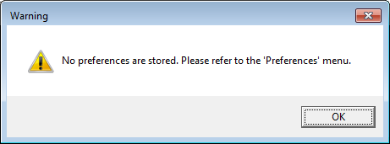

Pressing ‘OK’ on this message will allow you to continue to the home screen of the program. You will be presented with the following screen, which contains three important buttons with which you can interact with the program:

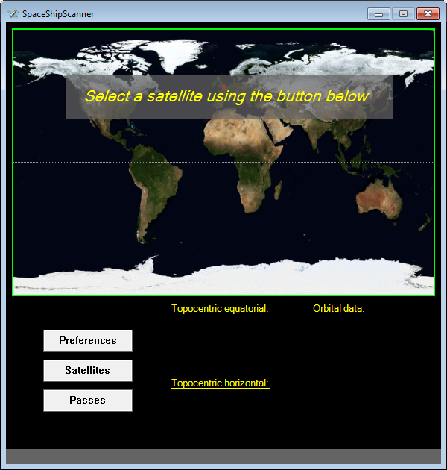

**The ‘Preferences’ button**

Before you can use SpaceShipScanner, you will need to take notice of the previous warning message and input some important information. This will allow the program to determine correct observational results when a satellite is selected. The values you enter can be updated at any time.

Pressing the ‘Preferences’ button will present you with the following menu:

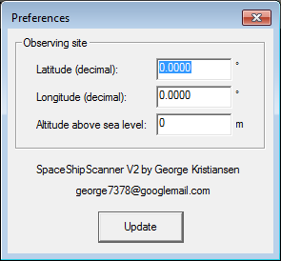

The information required by SpaceShipScanner is all related to the location from which you wish to observe a satellite.

The first option is *Latitude*. This is the ‘vertical’ angle between the Earth’s equatorial plane and your observing location. It must be between +90° (the North Pole) and -90° (the South Pole). It should be provided in decimal format (rather than Degrees : Minutes : Seconds).

Second, the observer’s *Longitude* must be entered. This is another angular value, measured from the Greenwich Meridian. It must be between +180° and -180°. Longitudes west of the Greenwich Meridian are negative, while those East of it are positive. -180° and +180° are equivalent, as travelling half way around the world in either an East or West direction will take you to the same longitudinal position.

Finally, the observer’s *Altitude* above sea level must be entered. This depends on your local terrain.

All three of these values can be found online in the correct format by consulting a web service such as http://www.mapcoordinates.net/en, or by using a GPS unit. Once you have entered this information, press ‘Update’ and you should be greeted with a confirmation message, as below:

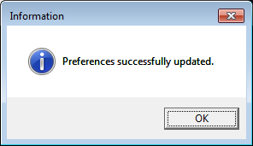

**The ‘Satellites’ button**

Once you have successfully stored your preferences, you are ready to select a satellite to observe. Pressing the ‘Satellites’ button will present you with the following screen:

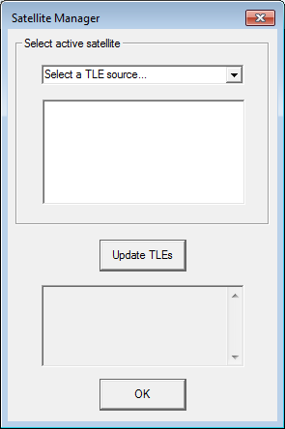

It may look blank to begin with, but this screen allows you to load and browse the hundreds of satellites which can be selected to observe within the program. Every time you use the program, it is important to ensure that the TLE database is up to date. SpaceShipScanner downloads a selection of files containing multiple TLEs from the many hosted at http://celestrak.com/NORAD/elements/. The files which the program accesses can be seen by opening the drop-down menu at the top of this window. Pressing the ‘Update TLEs’ button will cause the program to attempt to access the latest versions of these files from the celestrak website. The status box will cycle through the individual files and attempt to download them. If the process succeeds, the following message should be displayed:

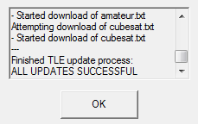

If the status box indicates that any of the files were not successfully downloaded, please ensure that you have good internet connectivity and try again.

IMPORTANT: *Internet Explorer* is required to allow the program to interface with the celestrak website and download the files.

Once your TLE database is up to date, you can choose a satellite using the ‘Select active satellite’ controls. First, you need to choose a directory file from which to load TLEs. These are the files which you have just downloaded during the update process. The files downloaded by SpaceShipScanner contain different groups of satellites. They are described below:

* stations.txt – this contains space stations and satellites relating to various manned missions.
* visual.txt – this contains some of the brightest observable satellites.
* weather.txt – this contains satellites used for weather applications.
* resource.txt – this contains satellites used for Earth monitoring.
* iridium.txt – this contains communications satellites from the Iridium constellation.
* science.txt – this contains scientific satellites.
* amateur.txt – this contains amateur radio satellites.
* cubesat.txt – this contains small experimental satellites.

Provided the TLE database is in good condition, choosing one of these files from the drop-down menu will populate the list with a selection of satellites. To load a satellite into the program, simply choose one from the list and click ‘OK’:

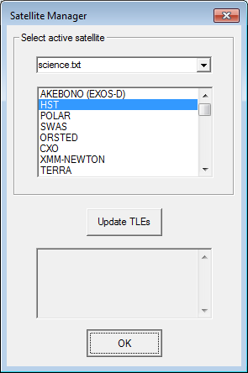

Upon the successful selection of a satellite, you will be returned to the main program interface, which will now contain a lot more information. It will look something like this:

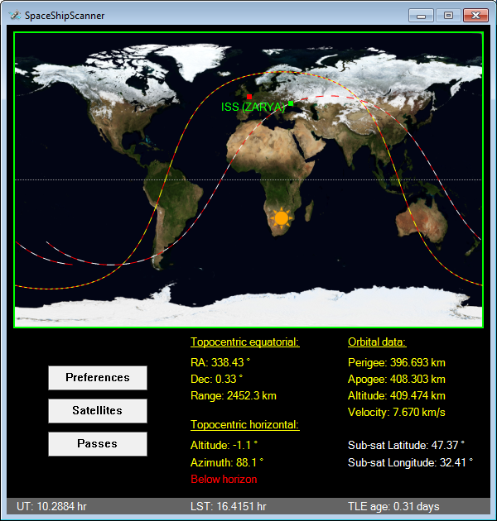

The program will update the display once per second. The satellite’s current location above Earth is marked with a green square (and a label with its name), while your observing location is marked with a red square. The Sun icon marks the location on Earth at which the Sun is directly overhead, while the red/yellow dashed curve shows the terminator between night and day. Any part of the map on the opposite side of the terminator to the Sun will be in shadow.

The second dashed line (red/white) marks the past and future ground track of the satellite. It plots 0.55 of an orbit into both the future and past to provide a good representation of the satellite’s movement in the near future, as well as the recent past.

The text fields underneath the map provide some useful observational data for the selected satellite. If you are unsure of the purpose of any of these text fields, a short internet search will reveal their meaning. Alternatively, you can observe how they evolve as the satellite travels across the map.

**The ‘Passes’ button**

The final button will present you with a menu much like this:

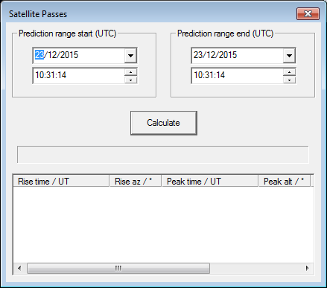

This tool will allow you to calculate passes for the current satellite. A pass is defined by the program as an interval during which the satellite rises above the observer’s horizon and reaches a minimum altitude of 10°.

You can define a time interval for which to make the pass predictions using the pre-populated start/end time selectors. It is important to note that the program works in Universal Coordinated Time (UTC), which may well differ from your local time zone. When the ‘Passes’ window is opened, the program will automatically enter the current date and time (in UTC) into both fields.

Provided a satellite is selected and the entered prediction range end is after the start, pressing ‘Calculate’ will populate the lower list with a series of values. Each row in the list represents a single pass, with the start time, peak time and end time displayed:

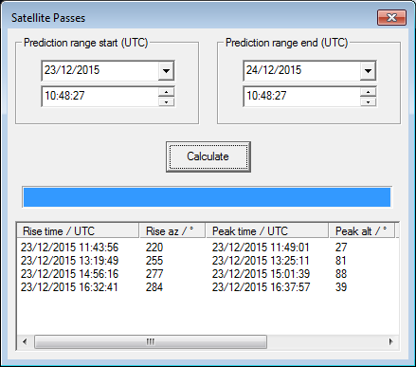

Please note that SpaceShipScanner does not currently distinguish passes which are visible (i.e. the satellite is illuminated and the sky is dark enough to allow it to be seen). This is likely to be added to a future update. The ‘Passes’ tool is currently designed to show you when the satellite will be above your horizon and to give you some idea of the path it will take through the sky. If the rise time coincides with a time just after sunset or just before sunrise, it is likely that the conditions will be favourable for observing the satellite.

**Conclusion**

While SpaceShipScanner is designed to be intuitive and easy to use, this manual should hopefully answer any questions you may have. If you would like to discuss the program or ask any further questions, please don’t hesitate to send a message to the email address at the top of this document.

Thanks! George Kristiansen.